Need of Set Operations

1. No duplicates in the result set.
2. All distinct rows.

JOINS vs Set Operations

|  |  |
| --- | --- |
| JOINS | Set Operations |
| No need of same set of attributes | Set of attributes must be same |
| Condition needs to met | No condition is required |
| Distinct columns are created | Distinct rows are created |

The various Set Operations are:

1. UNION
2. INTERSECTION
3. MINUS

UNION

The UNION operator is used to combine the result-set of two or more SELECT statements.

1. Every SELECT statement within UNION must have the same number of columns
2. The columns must also have similar data types
3. The columns in every SELECT statement must also be in the same order

SELECT column_name(s) FROM table1  
UNION  
SELECT column_name(s) FROM table2;

UNION ALL

The UNION operator selects only distinct values by default. To allow duplicate values, use UNION ALL:

SELECT column_name(s) FROM table1  
UNION ALL  
SELECT column_name(s) FROM table2;

The column names in the result-set are usually equal to the column names in the first SELECT statement.

INTERSECT

The INTERSECT operator is used to get the intersection of the result-set of two or more SELECT statements. INTERSECT operation returns only common rows in both queries after sorting them and removing duplicates.

1. Every SELECT statement within INTERSECT must have the same number of columns
2. The columns must also have similar data types
3. The columns in every SELECT statement must also be in the same order

SELECT DISTINCT INNER JOIN;

MINUS

MINUS operation returns only the rows present in the first table that don’t appear in the second table after sorting them and removing duplicates.

TABLE1 – TABLE2

SELECT TABLE1.COL1, TABLE1.COL2, TABLE1.COL3 …………

FROM TABLE1

LEFT JOIN TABLE2

ON TABLE1.COL = TABLE2.COL

WHERE TABLE2.COL IS NULL;

TABLE2 – TABLE1

SELECT TABLE2.COL1, TABLE2.COL2, TABLE2.COL3 …………

FROM TABLE1

RIGHT JOIN TABLE2

ON TABLE1.COL = TABLE2.COL

WHERE TABLE1.COL IS NULL;

#### Q80: Using the tables given below, list out all the employees of the company. The data should not contain duplicate rows of employees.

EMPDEPT1

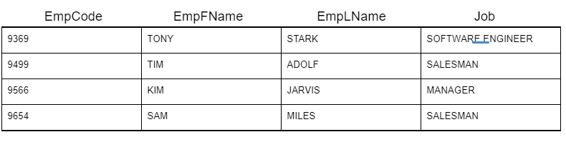

EMPDEPT2

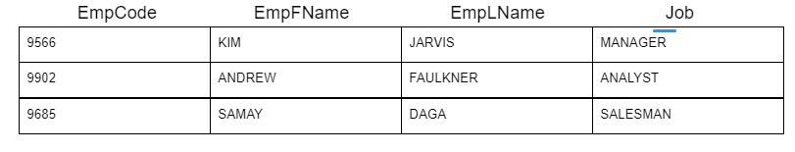

Ans:

SELECT * FROM EMPDEPT1

UNION

SELECT * FROM EMPDEPT2;

+---------+----------+----------+-------------------+

| EmpCode | EmpFName | EmpLName | Job |

+---------+----------+----------+-------------------+

| 9369 | TONY | STARK | SOFTWARE ENGINEER |

| 9499 | TIM | ADOLF | SALESMAN |

| 9566 | KIM | JARVIS | MANAGER |

| 9654 | SAM | MILES | SALESMAN |

| 9902 | ANDREW | FAULKNER | ANALYST |

| 9685 | SAMAY | DAGA | SALESMAN |

+---------+----------+----------+-------------------+

#### Q81: List down employees (all the details) from both the departments who work as Salesman. The data should contain duplicate rows of employees.

EMPDEPT1



EMPDEPT2



Ans:

SELECT * FROM EMPDEPT1 WHERE JOB = 'SALESMAN'

UNION ALL

SELECT * FROM EMPDEPT2 WHERE JOB = 'SALESMAN';

+---------+----------+----------+----------+

| EmpCode | EmpFName | EmpLName | Job |

+---------+----------+----------+----------+

| 9499 | TIM | ADOLF | SALESMAN |

| 9654 | SAM | MILES | SALESMAN |

| 9685 | SAMAY | DAGA | SALESMAN |

+---------+----------+----------+----------+

Q82: List out each employee name and employee code from both the departments and order them in ascending order by their code. Duplicates are allowed.

EMPDEPT1



EMPDEPT2



Ans:

SELECT EMPFNAME, EMPLNAME, EMPCODE FROM EMPDEPT1

UNION ALL

SELECT EMPFNAME, EMPLNAME, EMPCODE FROM EMPDEPT2

ORDER BY EMPCODE;

+----------+----------+---------+

| EMPFNAME | EMPLNAME | EMPCODE |

+----------+----------+---------+

| TONY | STARK | 9369 |

| TIM | ADOLF | 9499 |

| KIM | JARVIS | 9566 |

| KIM | JARVIS | 9566 |

| SAM | MILES | 9654 |

| SAMAY | DAGA | 9685 |

| ANDREW | FAULKNER | 9902 |

+----------+----------+---------+

Q83: Write a SQL query to print the item name, item type and price of all the items present in both the shops in descending order of their price.

SHOP_1 TABLE

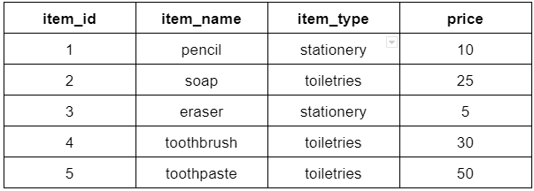

SHOP_2 TABLE

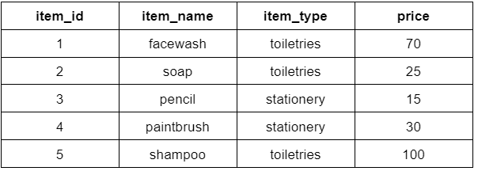

Ans:

SELECT ITEM_NAME, ITEM_TYPE, PRICE FROM SHOP_1

UNION ALL

SELECT ITEM_NAME, ITEM_TYPE, PRICE FROM SHOP_2

ORDER BY PRICE DESC;

+------------+------------+-------+

| ITEM_NAME | ITEM_TYPE | PRICE |

+------------+------------+-------+

| shampoo | toiletries | 100 |

| facewash | toiletries | 70 |

| toothpaste | toiletries | 50 |

| toothbrush | toiletries | 30 |

| paintbrush | stationery | 30 |

| soap | toiletries | 25 |

| soap | toiletries | 25 |

| pencil | stationery | 15 |

| pencil | stationery | 10 |

| eraser | stationery | 5 |

+------------+------------+-------+

Q84: Write a SQL query to get the item_name, price of items in shop_1 and shop_2 where price is greater than 25.

SHOP_1 TABLE



SHOP_2 TABLE



Ans:

SELECT ITEM_NAME, PRICE FROM SHOP_1 WHERE PRICE > 25

UNION ALL

SELECT ITEM_NAME, PRICE FROM SHOP_2 WHERE PRICE > 25;

+------------+------------+-------+

| ITEM_NAME | ITEM_TYPE | PRICE |

+------------+------------+-------+

| shampoo | toiletries | 100 |

| facewash | toiletries | 70 |

| toothpaste | toiletries | 50 |

| toothbrush | toiletries | 30 |

| paintbrush | stationery | 30 |

| soap | toiletries | 25 |

| soap | toiletries | 25 |

| pencil | stationery | 15 |

| pencil | stationery | 10 |

| eraser | stationery | 5 |

+------------+------------+-------+

Q85: Find out all the details of employees that work for both the departments. The data should not contain duplicate rows of employees

EMPDEPT1



EMPDEPT2



Ans:

SELECT DISTINCT EMPDEPT1.EMPCODE, EMPDEPT1.EMPFNAME, EMPDEPT1.EMPLNAME, EMPDEPT1.JOB

FROM EMPDEPT1

INNER JOIN EMPDEPT2

ON EMPDEPT1.EMPCODE = EMPDEPT2.EMPCODE;

+---------+----------+----------+---------+

| EMPCODE | EMPFNAME | EMPLNAME | JOB |

+---------+----------+----------+---------+

| 9566 | KIM | JARVIS | MANAGER |

+---------+----------+----------+---------+

Q86: Write a SQL query to find the item name along with its type of stationery item which is available in both the shops.

SHOP_1 TABLE



SHOP_2 TABLE



Ans:

SELECT DISTINCT SHOP_1.ITEM_NAME, SHOP_1.ITEM_TYPE

FROM SHOP_1

INNER JOIN SHOP_2

ON SHOP_1.ITEM_NAME = SHOP_2.ITEM_NAME

WHERE SHOP_1.ITEM_TYPE = 'stationery';

Q87: Write a SQL query to find the name and price of items whose price is greater than 20 and available in both the shops.

SHOP_1 TABLE



SHOP_2 TABLE



Ans:

SELECT DISTINCT SHOP_1.ITEM_NAME, SHOP_1.PRICE

FROM SHOP_1

INNER JOIN SHOP_2

ON SHOP_1.ITEM_NAME = SHOP_2.ITEM_NAME

WHERE SHOP_1.PRICE > 20;

+-----------+-------+

| ITEM_NAME | PRICE |

+-----------+-------+

| soap | 25 |

+-----------+-------+

Q88: List down all the details of employees working in dept1 but not in Dept2.

EMPDEPT1



EMPDEPT2



Ans:

SELECT EMPDEPT1.EMPCODE, EMPDEPT1.EMPFNAME, EMPDEPT1.EMPLNAME, EMPDEPT1.JOB

FROM EMPDEPT1

LEFT JOIN EMPDEPT2

ON EMPDEPT1.EMPCODE = EMPDEPT2.EMPCODE

WHERE EMPDEPT2.EMPCODE IS NULL;

+---------+----------+----------+-------------------+

| EMPCODE | EMPFNAME | EMPLNAME | JOB |

+---------+----------+----------+-------------------+

| 9369 | TONY | STARK | SOFTWARE ENGINEER |

| 9499 | TIM | ADOLF | SALESMAN |

| 9654 | SAM | MILES | SALESMAN |

+---------+----------+----------+-------------------+

Q89: Write a SQL query to print the item name, item type of only the items which are available in shop 1 but not in shop 2 in the ascending order of item name.

SHOP_1 TABLE



SHOP_2 TABLE



Ans:

SELECT SHOP_1.ITEM_NAME, SHOP_1.ITEM_TYPE

FROM SHOP_1

LEFT JOIN SHOP_2

ON SHOP_1.ITEM_NAME = SHOP_2.ITEM_NAME

WHERE SHOP_2.ITEM_NAME IS NULL

ORDER BY SHOP_1.ITEM_NAME;

+------------+------------+

| ITEM_NAME | ITEM_TYPE |

+------------+------------+

| eraser | stationery |

| toothbrush | toiletries |

| toothpaste | toiletries |

+------------+------------+

Q90: Write a SQL query to print the item name, price of only the items which are available in shop 2 but not in shop 1 whose price is greater than 50.

SHOP_1 TABLE



SHOP_2 TABLE



Ans:

SELECT SHOP_2.ITEM_NAME, SHOP_2.PRICE

FROM SHOP_1

RIGHT JOIN SHOP_2

ON SHOP_1.ITEM_NAME = SHOP_2.ITEM_NAME

WHERE SHOP_1.ITEM_NAME IS NULL AND SHOP_2.PRICE > 50;

+-----------+-------+

| ITEM_NAME | PRICE |

+-----------+-------+

| facewash | 70 |

| shampoo | 100 |

+-----------+-------+